Group Number: _____ Date(s) and Time(s) of Drive Around: ______________ Group Leader: _______________
Group Members: (names-all) ___________________________________________________________________________

Nurses must be able to knowledgeably plan services for individuals, families and the community. In order to effectively plan, it is essential that you are aware of the resources specific to the community a client resides in to allow for identification of health-related resources and to understand gaps in services. A windshield survey is conducted from a car and provides a visual overview of a community. Conditions and trends in the community that could affect the health of the population should be noted. This data provides background and context for working with individuals and families in their community. Information gathered from this survey can be used to help with developing the power point presentation.

Points:
Integration of this information into the group power point presentation will provide evidence for awarding possible 100 points.

Clinical Hours:
Completion of this document will provide evidence for awarding skills lab hours.

Directions:
- Each member of the team must upload the completed Wind Shield Survey Tool into the drop box in order to have evidence of completion for receiving skills hours.
- Conduct a group Windshield Survey of your assigned community (zip codes). Preferably on the weekend which will most likely provide a more accurate representation of the population activity. It is also preferable of all members of the team participate in this survey. You can split the group in two and each group take a zip code, or you can all go together.
- Take pictures/videos that represent your community’s overall environment. Add a minimum of three pictures per element in the identified areas of this tool. (please keep them small to fit in the boxes)
- Not all elements may have pictorial representations, if there are no pictorial representations for an element, you must still place notes answering the questions, and then identify in the first box that you were unable to identify any picture for that element.
- Integrate the Windshield findings and pictures into the power point presentation. (you do not have to use all the pictures here in the PPP)
- Always maintain individual and group safety .

Notes and Pictures
Boundaries:
Are the boundaries geographical, political, or economic?
Do neighborhoods have names? Are there sub-communities? How are these identified?
Notes:
- The sentinel Town boundaries are geographical and also economical as you move around. The major boundary landmarks are signposts that alert an individual that he or she is entering a new neighborhood. Looking at the building and the holes, one would be able to detect a shift in the economic condition of a given neighborhood. The industrial height area has sinkholes and graffiti on the building. Some neighborhoods are filthy with garbage, while others, such as the industrial heights, are filthy with heaps of garbage.
- Yes, the community have names; one is the Nightingale Square was Sentinel City's first neighborhood. The sidewalks and streets are clean and well-kept, and the buildings are mostly large and bright. The second community is Acer Tech Center, which has mostly clean sidewalks and streets, well-kept buildings, more garbage carriers outside buildings, nice sidewalks, and slightly more graffiti than Nightingale Square, but not too much. There is also Casper Park district.
Pictures:  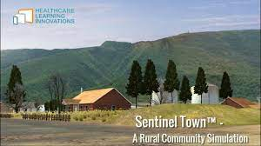 | 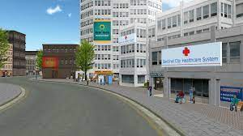 | 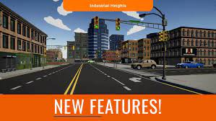
Housing and Zoning:
In general, how old are the buildings? Are the residences single family or multifamily dwellings? Are there track housing, trailer parks? Are homes in good repair? Abandoned boarded houses?
Notes:
- The house buildings include both old and new structures. Because of industrial air pollution, the building heights are old and covered in graffiti.
- The majority of the residents are multifamily, but some are single.
- Yes, there is track housing as well as trailer parks.
- The modern homes are in good condition, and they are built with bricks, have air conditioning, modern plumbing, and some are painted.
- There are some abandoned boarded-up houses.
Pictures:  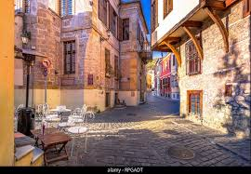 | 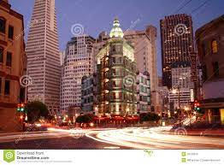 | 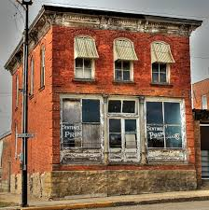
Signs of Decay:
Is the area well maintained or in disrepair? Is there garbage strewn? Are there trashed/abandoned cars, places for rodents or other wildlife to hide, vacant lots?
Notes:
- Some parts of the area within the community are well maintained but some are not.
- There is garbage strewn and abandoned cars along the way
- Yes, there are vacant slots where some animals can hide on.

Pictures:  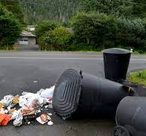 | 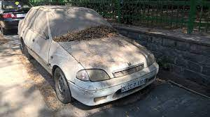 | 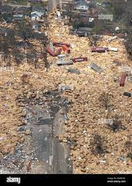
Parks and Recreational Areas:
Are there play areas for children and adults? Are they safe and maintained? Is there any kind of Community Center? Libraries?
Notes:
- Yes, there are areas for both children and adults to play. There are children playing in the schoolyard, as well as adults playing tennis and basketball at the recreation center.
- They are secure and well-kept.
- Yes, there is a library and a community.
Pictures:  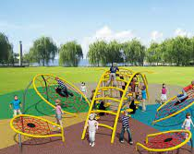 | 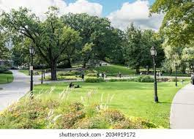 | 
Common Areas:
Where do people collect for social gatherings; where do they “hang out”? Are they for particular groups or are they open to all? Are there signs posted? Is there tagging in the area?
Notes:
- People congregate in coffee shops, bars, and restaurants for social gatherings.
- They hang out in the city's Nightingale Square, where there is a tennis court and also some in parks.
- It is for peers and adults to compete in tennis and bicycle riding competitions.

- Yes, there are signs, and there is also a tagging in the area.
Pictures:  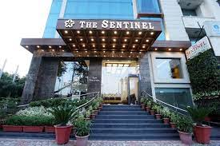 |  | 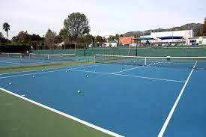
Stores:
What stores (grocery, retail, pharmacy, liquor, smoke shops, dry cleaning, etc.) are in the area? How do residents travel to them?
Notes:

- Sentinel City is densely packed with retail establishments. These include the Downtown Store and Joe's Grocery in Nightingale Square, a fruit stand, donut shop, and also there is a large drugstore, a dentist office, and a barber shop nearby.in Acer Tech, a small clothing boutique in Casper Park, and a bodega in Industrial Heights.
- Some the residents are walking to the stores while others use personal means by using cars.
Pictures: | 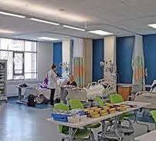 | 
Transportation:
How do most people get around the area? Is there public transportation? If so what kind and does it appear to be used? Who uses it? What is the condition of the streets, roads, highways?
Notes:
- The majority of people use public transportation by use of bus, some walk, others ride the bicycles and some individuals uses private cars.
- Yes, there is public transportation, and it is used by people with low living expenses.
- The only roads that have been maintained are those within the city limits. There are several sinkholes in the neighborhoods that could cause an accident. There is a highway that connects the city to the neighborhood for transportation purposes.
Pictures:  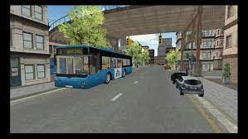 | 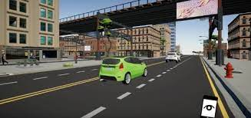 | 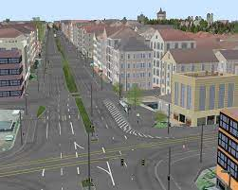
Communication:
Is there evidence of local and national newspapers to other media? Are there informational posters on streets, busses, billboards, etc.?
Notes:
- There is media presence due to satellite dishes strategically put in place.
- Sentinel Post is one of the popular magazines in the area, and it covers events in the political and social arenas. Aside from television and social media, the magazine is the best-selling media channel that people enjoy.
- The city's media is mostly comprised of billboards, with the only visible broadcast media being the radio station.
Pictures:  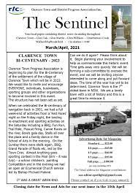 | 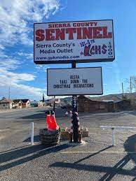 | 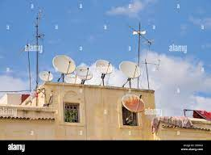
Service Centers:
What services are available in the community – health care, social services, schools, employment offices etc.?
Notes:
- Sentinel City appears to place a high value on health care. On the border of Nightingale Square and Acer Tech is the Healthcare System emergency room and outpatient clinic, as well as a dentist's office. In Industrial Heights, there is also a small health clinic. Social services are available where people gather and also schools for children where they learn and gain knowledge.
Pictures:  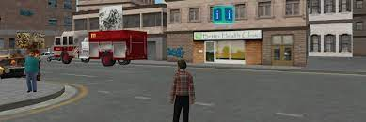 | 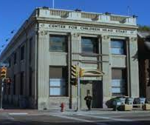 | 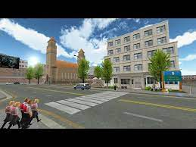
People in the Community:
Who is in the area during the day? What evidence is thereof particular “classes” of people – upper, middle, working, lower?
Notes:
- There are people who are walking along the way during the day. There are also stray dogs and cats along the way within the community neighborhood.
- They are lower class of people; these are individual walking to different places to look to minor jobs. So, that at the end of the day, they can get little money to purchase food.
Pictures:  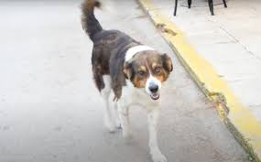 | 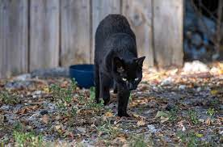 | 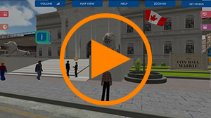
Industries:
What are the major industries located in the area? What types of occupations are evident?
Notes:
- There are food processing industries, telecommunication industries textile and leather industries
- Banking services are available and majority are employed.
Pictures:  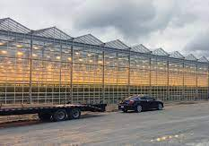 | 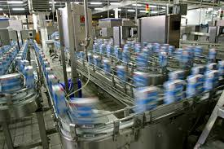 | 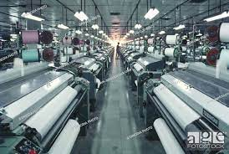
Protective Services:
Where are fire and police stations located? Is there evidence of police and fire protection in the area?
Notes:
- The police stations and fire departments are located along the main route within the city. To ease access, in case of emergency purposes. Fires hydrants are also located along the sidewalks.
- There are police station buildings. There were also police officers walking through the streets. Fire hydrants can be found throughout Sentinel City, and a Fire Department responds to car and emergency fires in Industrial Heights.
Pictures:  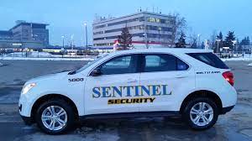 | 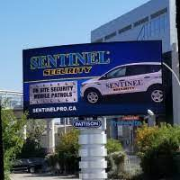 | 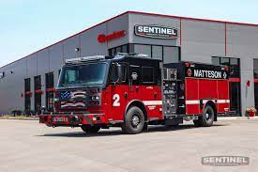
Ethnicity:
What is the predominant ethnic group? Are there residents from a variety of ethnic backgrounds or is the community mostly one group? Which one? Are there stores, restaurants, churches, schools, or languages that indicate a particular ethnic group(s)?
Notes:
- The predominant ethnic group are the rich individuals whereby their children are going to school with personal cars. They are also frequented the Bodega food store. That’s their store for buying food items.
- There rich are only living in one area and the private schools are only located within their locality. While public schools are located in areas with low-income families.
- There are churches and mosques. The Muslims are being distinguished by clothes they are wearing. The presence of women in veils and men in white and black robes indicated the presence of people of the Muslim faith.
- There was also sign post with Spanish language.

Pictures:  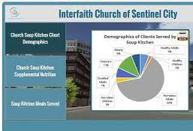 |  | 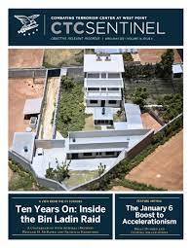
Religion:
What churches and church-run schools are in the area (denomination)? How many are there of each denomination?
Notes:
- Within Sentinel City, there are two religions. The presence of churches and mosques, as well as the clothing of some of the people in the area, represented Christianity and Islam. The number of churches outnumbers the number of mosques.
Pictures:  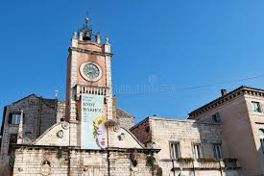 | 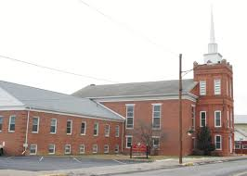 | 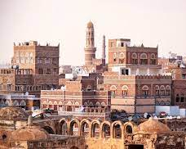
Health and Morbidity:
Is there evidence of any health problems such as drug/alcohol abuse, communicable or chronic diseases, mental illness (etc)?
Notes:
- As things currently stand in Sentinel City, the greatest population is at risk when it comes to health issues. One of the most pressing issues is the lack of food. Many people go hungry as a result of a difficult economic situation.
- Malnutrition is a problem for children. Sanitation is still a problem that endangers people's health in Sentinel City.
- Many gastrointestinal problems occur, due to wastes that are not properly disposed of.
The city's STI prevalence is increasing; the main cause of disease in this city is unprotected early sexual engagements. There are also early pregnancies at younger ages, which is attributed to the region.
Pictures:  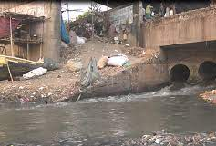 | 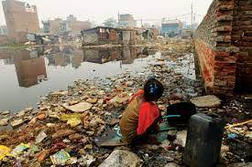 | 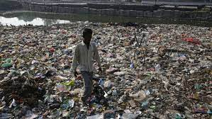
Politics:
Is there evidence of political activity? Are there any signs that indicate a predominant political?
party (parties) or concern(s)? (You may or may not find pictorial evidence of this)
Notes:
- Yes, there is political evidence.
- I came across various posters that were used during previous political periods. The political scene in the area is quite active. They have the democratic right to vote for whomever they want. The display of posters indicates that they are going through the proper legal process.
Pictures:  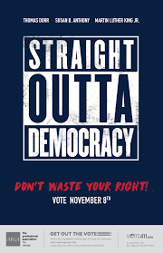 |  | 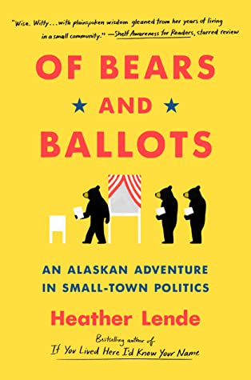

RUBRIC
Criteria | Criterion Details | Possible Points
Content | All identified elements of the document completed.  Notes provided for all community 16 elements. | 0 – 25
Group Participation | All group members participated in the drive-around. | 0 – 25
Media | Sufficient and appropriate pictures (or other media) taken for all 16 elements | 0 – 25
Power Point | Pictures (or other media) effectively incorporated into the PPP | 0 – 25
Completed on Time | See deduction as per school policy for late work
 | Total Possible Points | 100

